**Create Positive Adjustment Entries on Receipt**

**Case 1:**

Purchase Order:

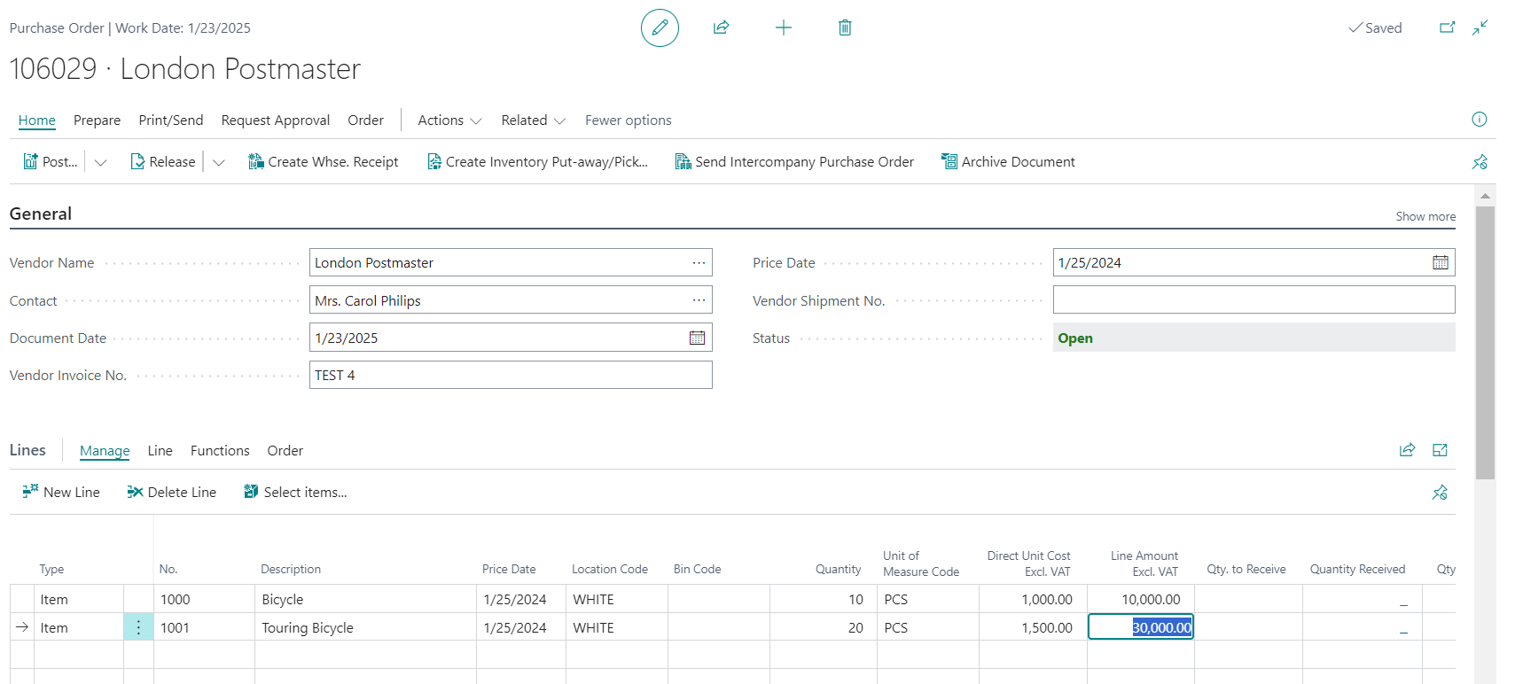

Warehouse Receipt:

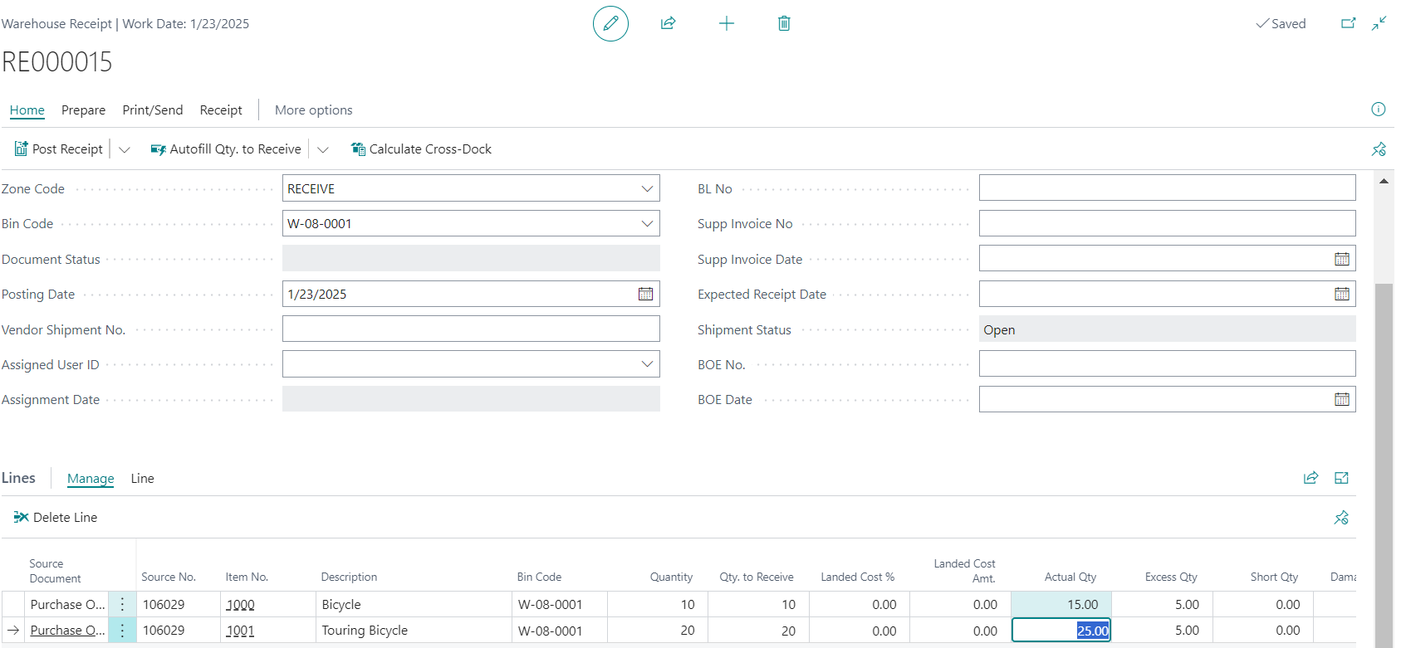

Posted Warehouse Receipt:

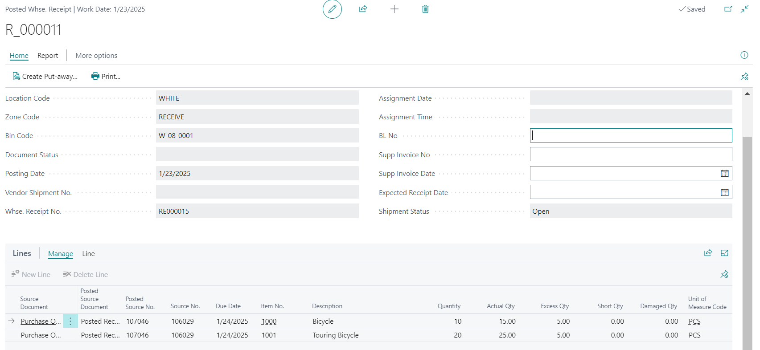

Location:

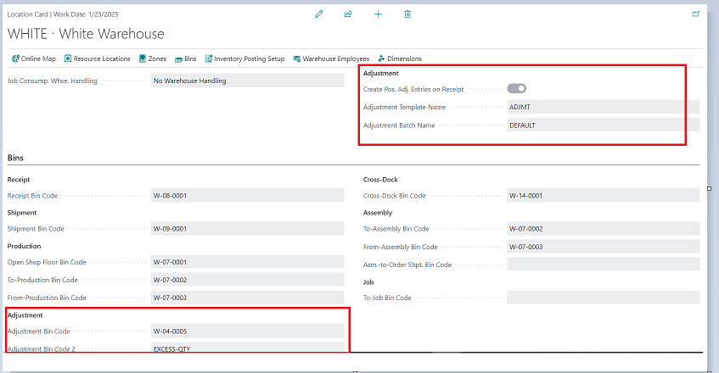

Warehouse Item Journal:



**Case 2:**

**Purchase Order:**

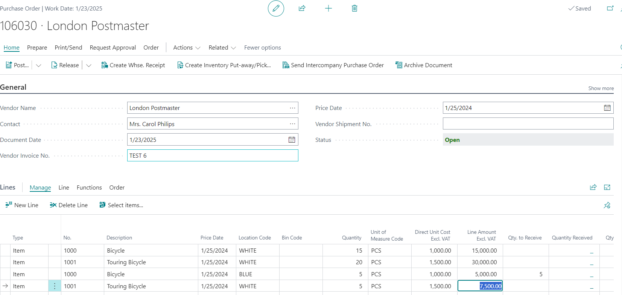

**Warehouse Receipt:**

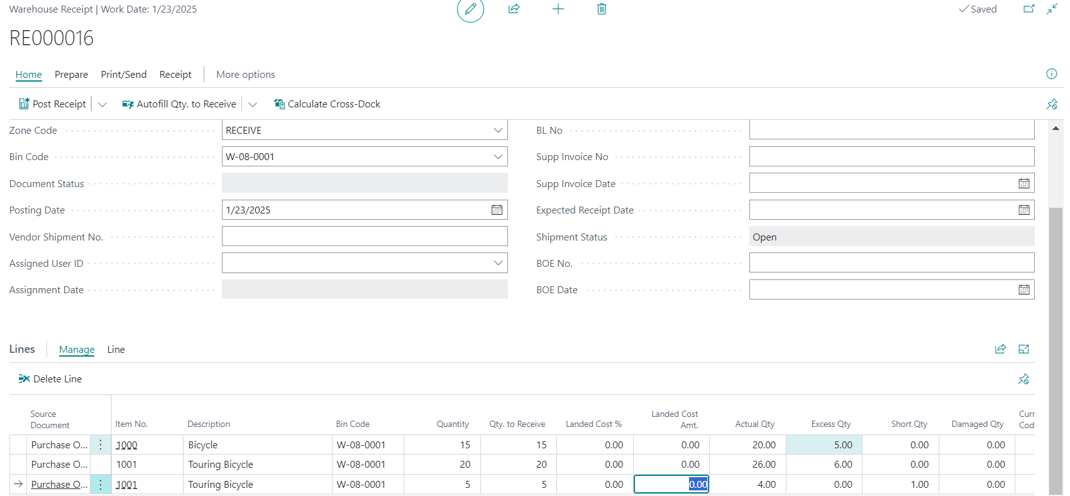

**Posted Warehouse Receipt:**

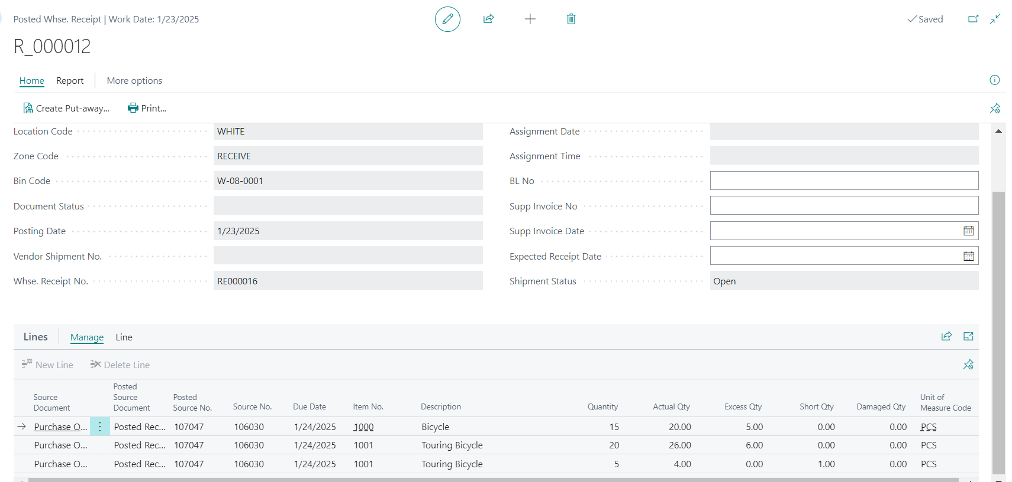

**Warehouse Item Journal:**

